

# *UniX and Linux Essentials*

**ASSIGNMENT - 4**

**SUBMITTED BY:**

**AYUSH KUMAR JHA**

**SAP ID - 500086400**

**Enrollment no - R200220083**

**B.C.A -I.O.T. -FIRST YEAR**

**Assignment 4: -**

**PWD files:-**

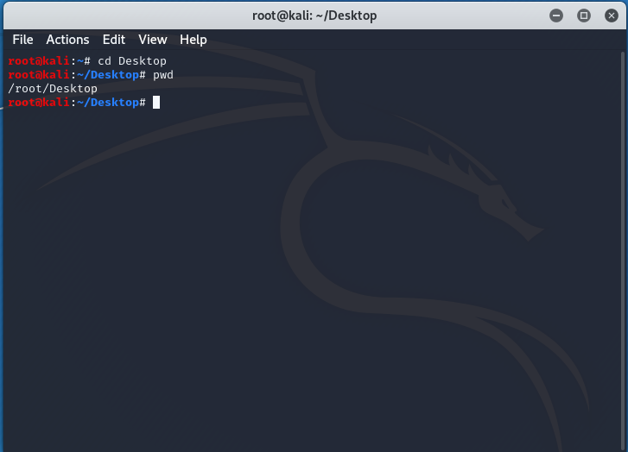

**LS :-**

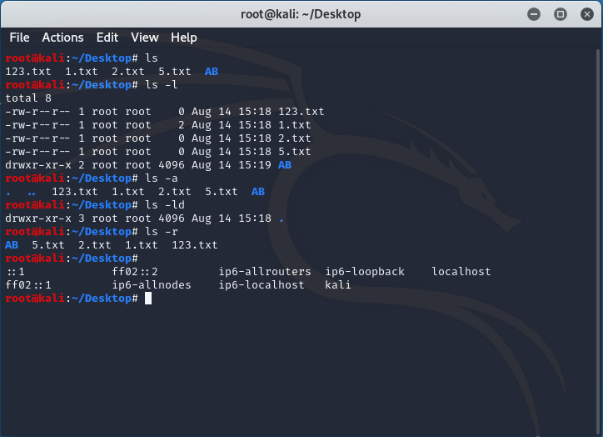

**File :-**

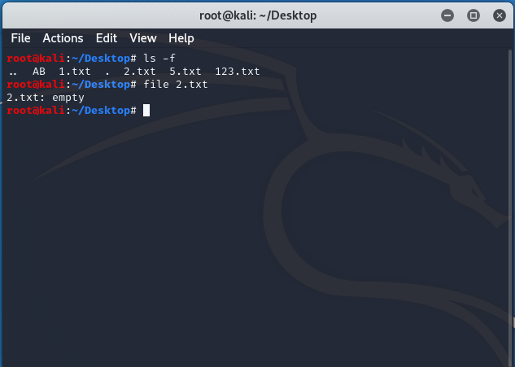

**CD :-**

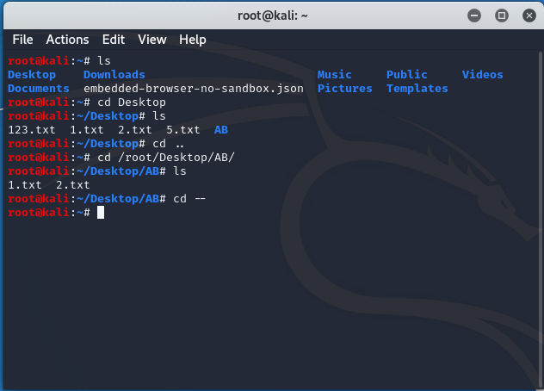

**CAT :-**

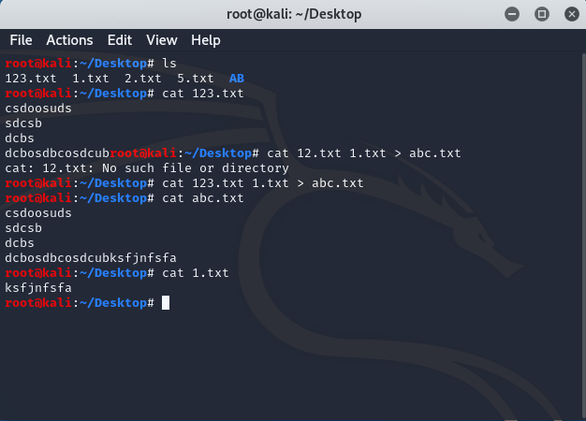

**More :-**

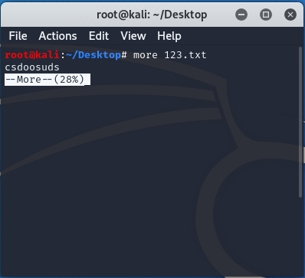

**Less :-**

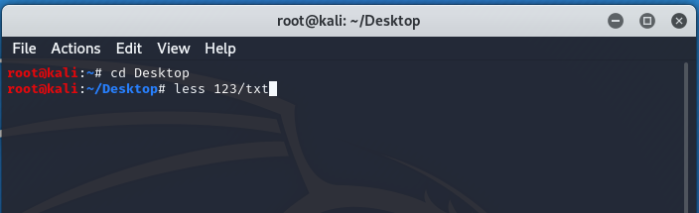

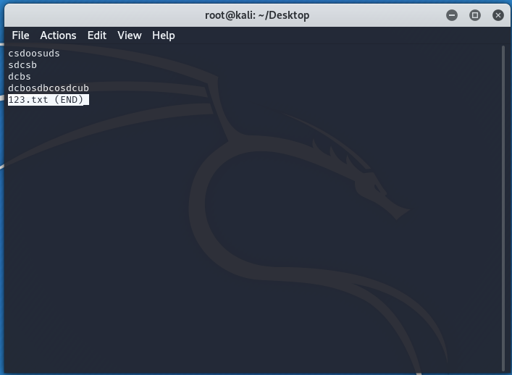

**Head :-**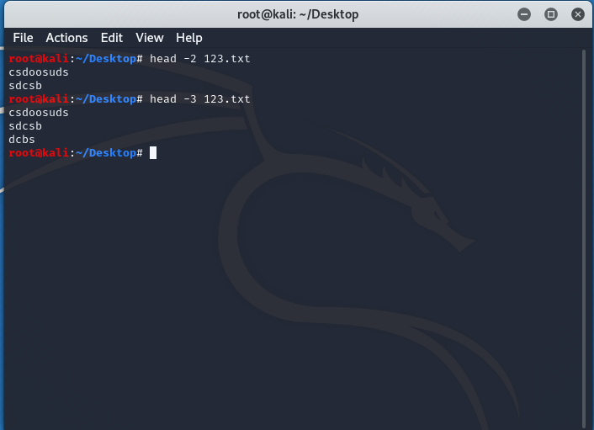

**Tail :-**

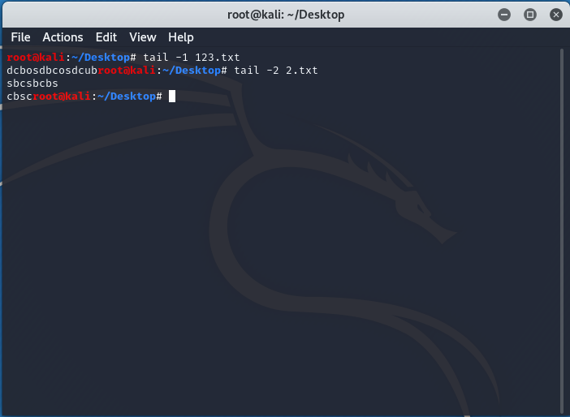

**WC :-**

